**The Method of Checking Selection Result of Tuition Fee Exemption at UTAS**

Tuition Fee Exemption: please check the page at UTAS as bellow.

URL: <https://utas.adm.u-tokyo.ac.jp/campusweb/>

After logging in...(PC ver.)

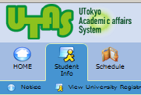



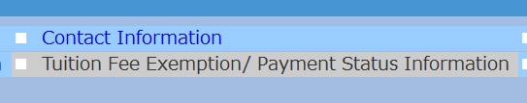

Please click on

“Tuition Fee Exemption/Payment Status　Information”.

